MODULE 1

SECTION 5.1

1. Using a ternary operator, write an if/else statement that will return true or false if the variable x is less than or equal to 7

public class Main

{

public static void main(String[] args)

{

int x = 5;

boolean result = (x <= 7) ? true : false;

System.out.println(result);

}

**OUTPUT:**

True

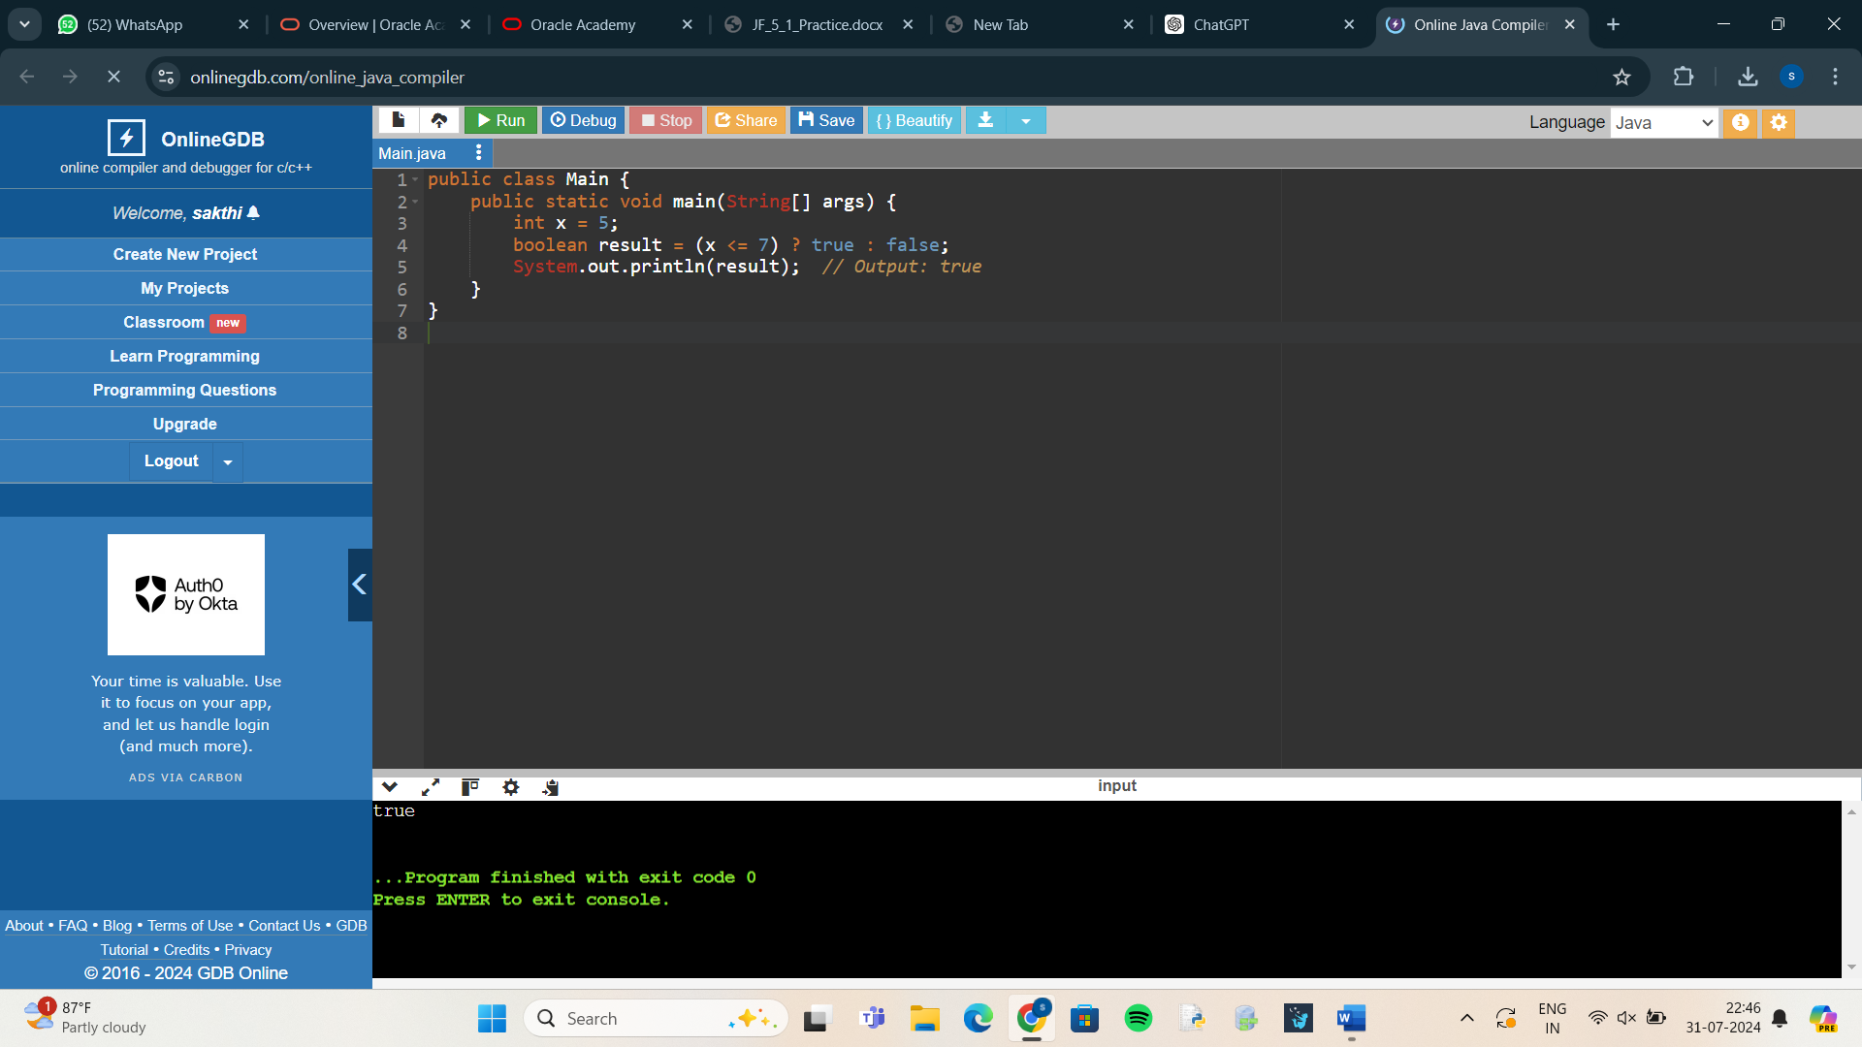

1. Write a program that prompts the user to enter two floating point (double) numbers and an operator ( *, +, /, %, -). Print the results of the given operation. For reading the command line, use the Scanner class. Write the program first using switch logic, then re-write the program using if/else logic.

**USING SWITCH LOGIC:**

import java.util.Scanner;

public class CalculatorSwitch {

public static void main(String[] args) {

Scanner scanner = new Scanner(System.in);

System.out.print("Enter first number: ");

double num1 = scanner.nextDouble();

System.out.print("Enter second number: ");

double num2 = scanner.nextDouble();

System.out.print("Enter an operator (+, -, *, /, %): ");

char operator = scanner.next().charAt(0);

double result;

switch (operator)

{

case '+':

result = num1 + num2;

break;

case '-':

result = num1 - num2;

break;

case '*':

result = num1 * num2;

break;

case '/':

if (num2 != 0) {

result = num1 / num2;

}

else

{

System.out.println("Error! Division by zero.");

return;

}

break;

case '%':

if (num2 != 0) {

result = num1 % num2;

} else {

System.out.println("Error! Division by zero.");

return;

}

break;

default:

System.out.println("Invalid operator!");

return;

}

System.out.println("The result is: " + result);

}

}

**USING IF/ELSE LOGIC:**

import java.util.Scanner;

public class CalculatorIfElse {

public static void main(String[] args) {

Scanner scanner = new Scanner(System.in);

System.out.print("Enter first number: ");

double num1 = scanner.nextDouble();

System.out.print("Enter second number: ");

double num2 = scanner.nextDouble();

System.out.print("Enter an operator (+, -, *, /, %): ");

char operator = scanner.next().charAt(0);

double result;

if (operator == '+') {

result = num1 + num2;

} else if (operator == '-') {

result = num1 - num2;

} else if (operator == '*') {

result = num1 * num2;

} else if (operator == '/') {

if (num2 != 0) {

result = num1 / num2;

} else {

System.out.println("Error! Division by zero.");

return;

}

} else if (operator == '%') {

if (num2 != 0) {

result = num1 % num2;

} else {

System.out.println("Error! Division by zero.");

return;

}

} else {

System.out.println("Invalid operator!");

return;

}

// Print the result

System.out.println("The result is: " + result);

}

}

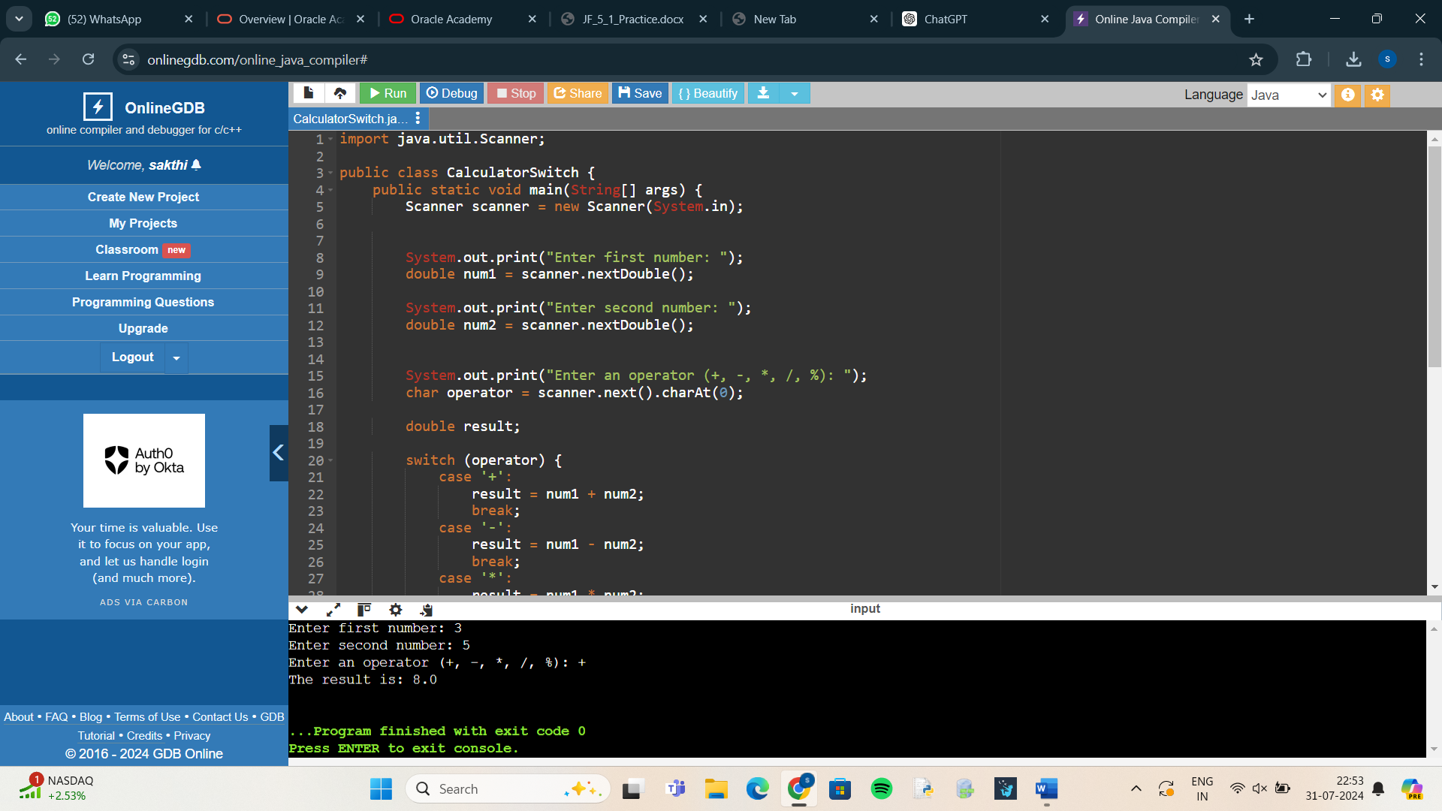

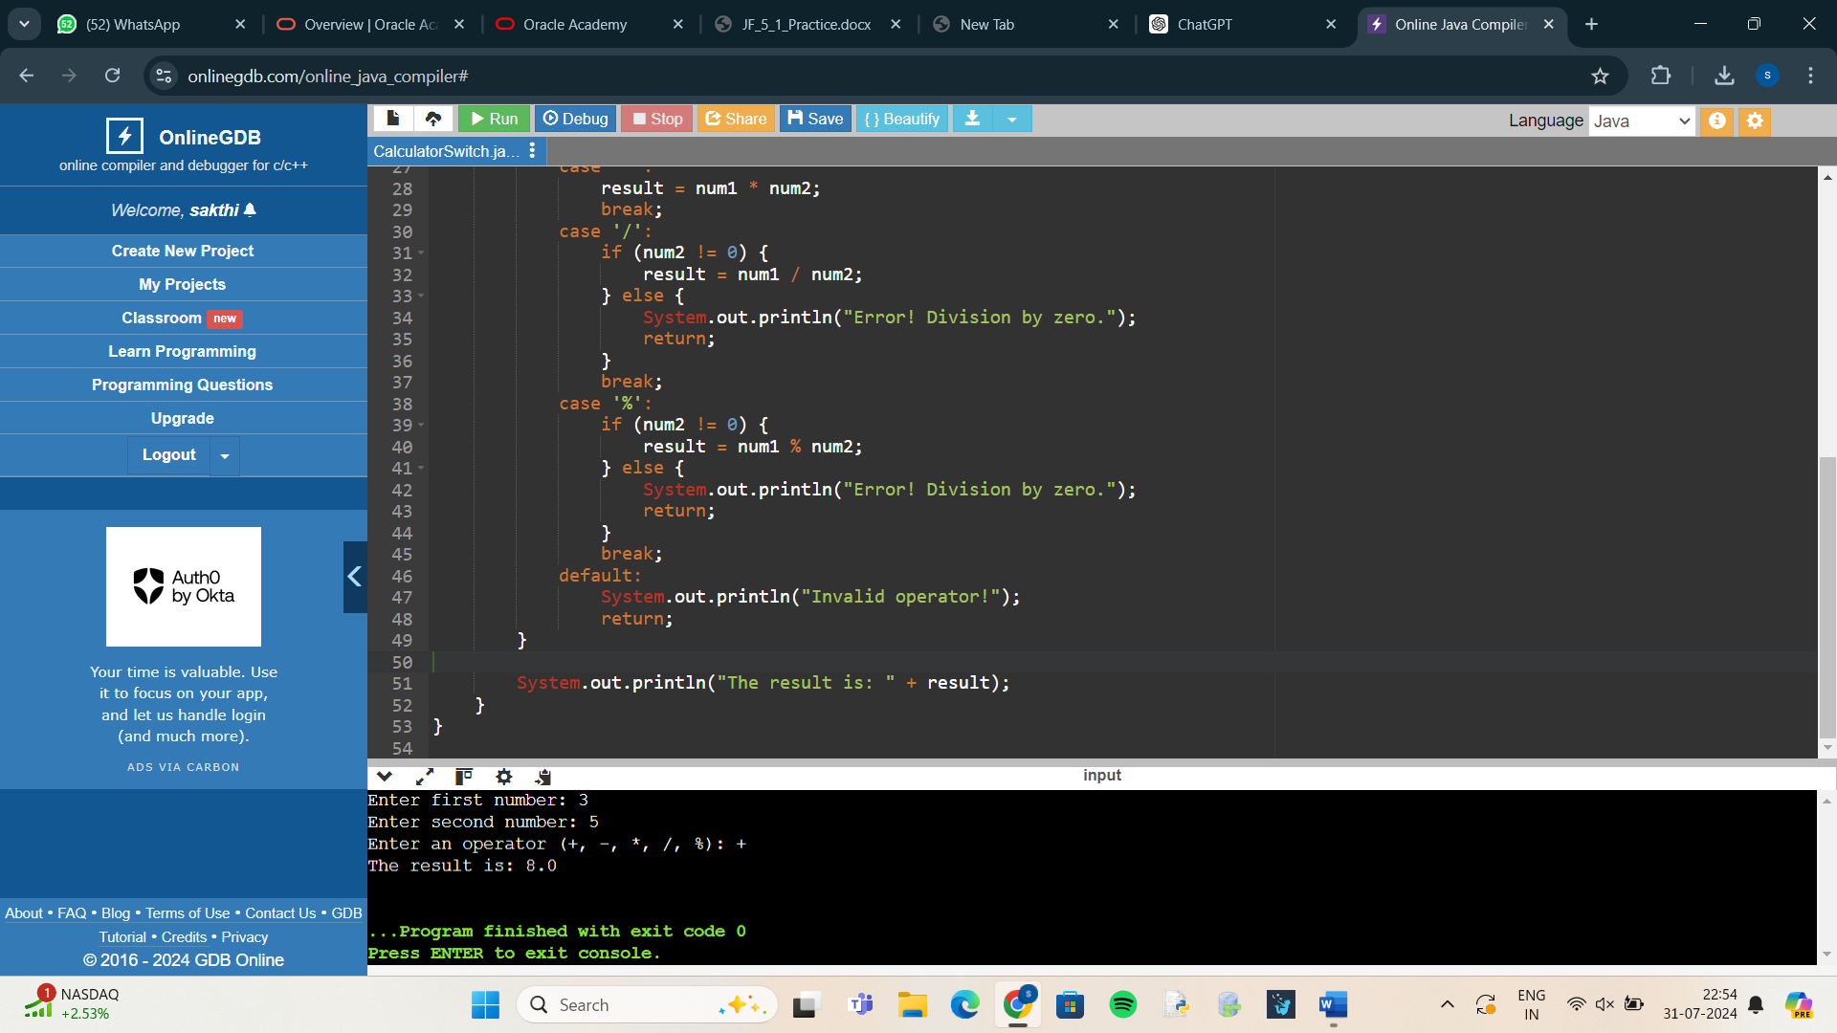

1. True or False: IF/ELSE statements can always be replaced with SWITCH statements.

**Answer**:True

1. Write a Java program to do the following that determines your weight on another planet. The program should ask for the user's weight on Earth, then present a menu of the other planets in our solar system. The user should choose one of the planets from the menu. The program should display the phrase like the following: “Your weight on Mars is 55 lbs.” Use the following conversion factors: Planet Conversion factor (multiply your Earth weight by this number to determine your weight on this planet) Mercury 0.38

Venus 0.91

Mars. 0.38

Jupiter 2.36

Saturn 0.92

Uranus 0.89

Neptune 1.13

**Answer:**

import java.util.Scanner;

public class PlanetWeightCalculator {

public static void main(String[] args) {

Scanner scanner = new Scanner(System.in);

System.out.print("Enter your weight on Earth (in lbs): ");

double earthWeight = scanner.nextDouble();

System.out.println("Choose a planet from the following menu:");

System.out.println("1. Mercury");

System.out.println("2. Venus");

System.out.println("3. Mars");

System.out.println("4. Jupiter");

System.out.println("5. Saturn");

System.out.println("6. Uranus");

System.out.println("7. Neptune");

System.out.print("Enter the number corresponding to your choice: ");

int choice = scanner.nextInt();

double conversionFactor = 0;

String planetName = "";

switch (choice) {

case 1:

conversionFactor = 0.38;

planetName = "Mercury";

break;

case 2:

conversionFactor = 0.91;

planetName = "Venus";

break;

case 3:

conversionFactor = 0.38;

planetName = "Mars";

break;

case 4:

conversionFactor = 2.36;

planetName = "Jupiter";

break;

case 5:

conversionFactor = 0.92;

planetName = "Saturn";

break;

case 6:

conversionFactor = 0.89;

planetName = "Uranus";

break;

case 7:

conversionFactor = 1.13;

planetName = "Neptune";

break;

default:

System.out.println("Invalid choice!");

return;

}

double planetWeight = earthWeight * conversionFactor;

System.out.println("Your weight on " + planetName + " is " + planetWeight + " lbs.");

}

}

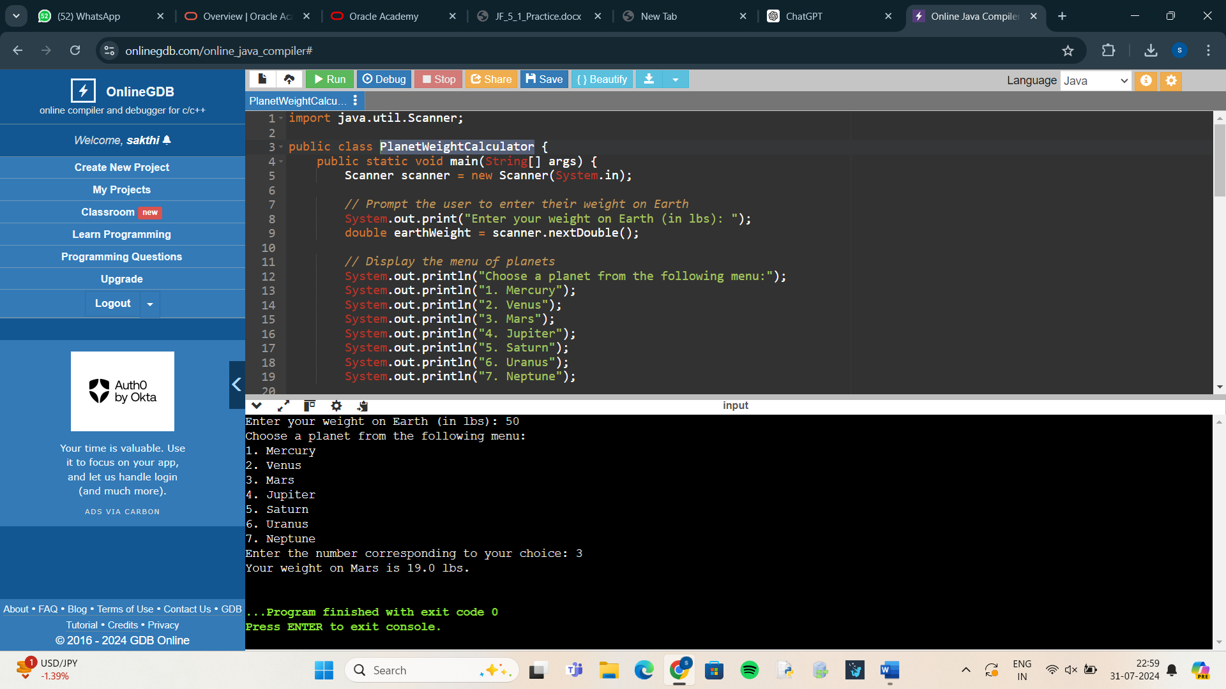

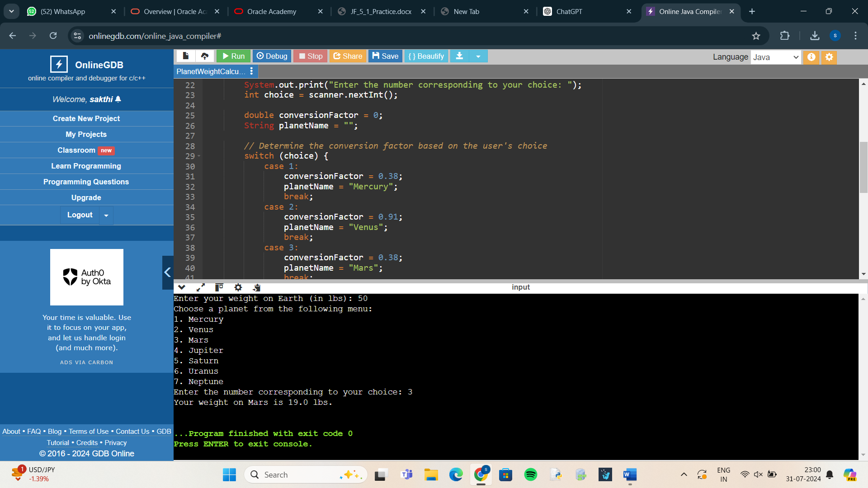

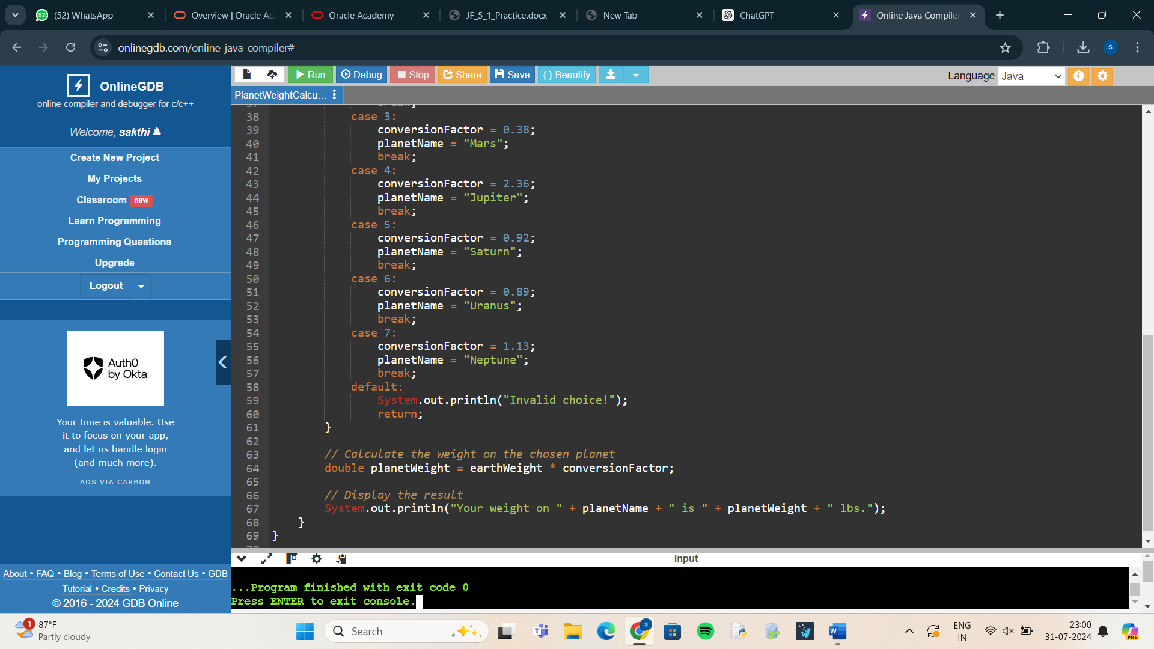

1. Write a Java program that will decide if a student gets into Mountville University. Students must have one of the following criteria: • been a valedictorian or salutatorian of a school of 1400 or more • had a gpa of 4.0 or better and a SAT score of 1100 or more • had a gpa of 3.5 or better and an SAT score of 1300 or more • had a gpa of 3.0 or better and an SAT score of 1500 or more

**ANSWER:**

import java.util.Scanner;

public class MountvilleUniversityAdmission {

public static void main(String[] args) {

Scanner scanner = new Scanner(System.in);

System.out.print("Are you a valedictorian or salutatorian of a school with 1400 or more students? (yes/no): ");

String isValedictorianOrSalutatorian = scanner.next().toLowerCase();

if (isValedictorianOrSalutatorian.equals("yes")) {

System.out.println("Congratulations! You are admitted to Mountville University.");

return;

}

System.out.print("Enter your GPA: ");

double gpa = scanner.nextDouble();

System.out.print("Enter your SAT score: ");

int satScore = scanner.nextInt();

boolean isAdmitted = (gpa >= 4.0 && satScore >= 1100) ||

(gpa >= 3.5 && satScore >= 1300) ||

(gpa >= 3.0 && satScore >= 1500);

if (isAdmitted) {

System.out.println("Congratulations! You are admitted to Mountville University.");

} else {

System.out.println("Sorry, you do not meet the admission criteria for Mountville University.");

}

}

}

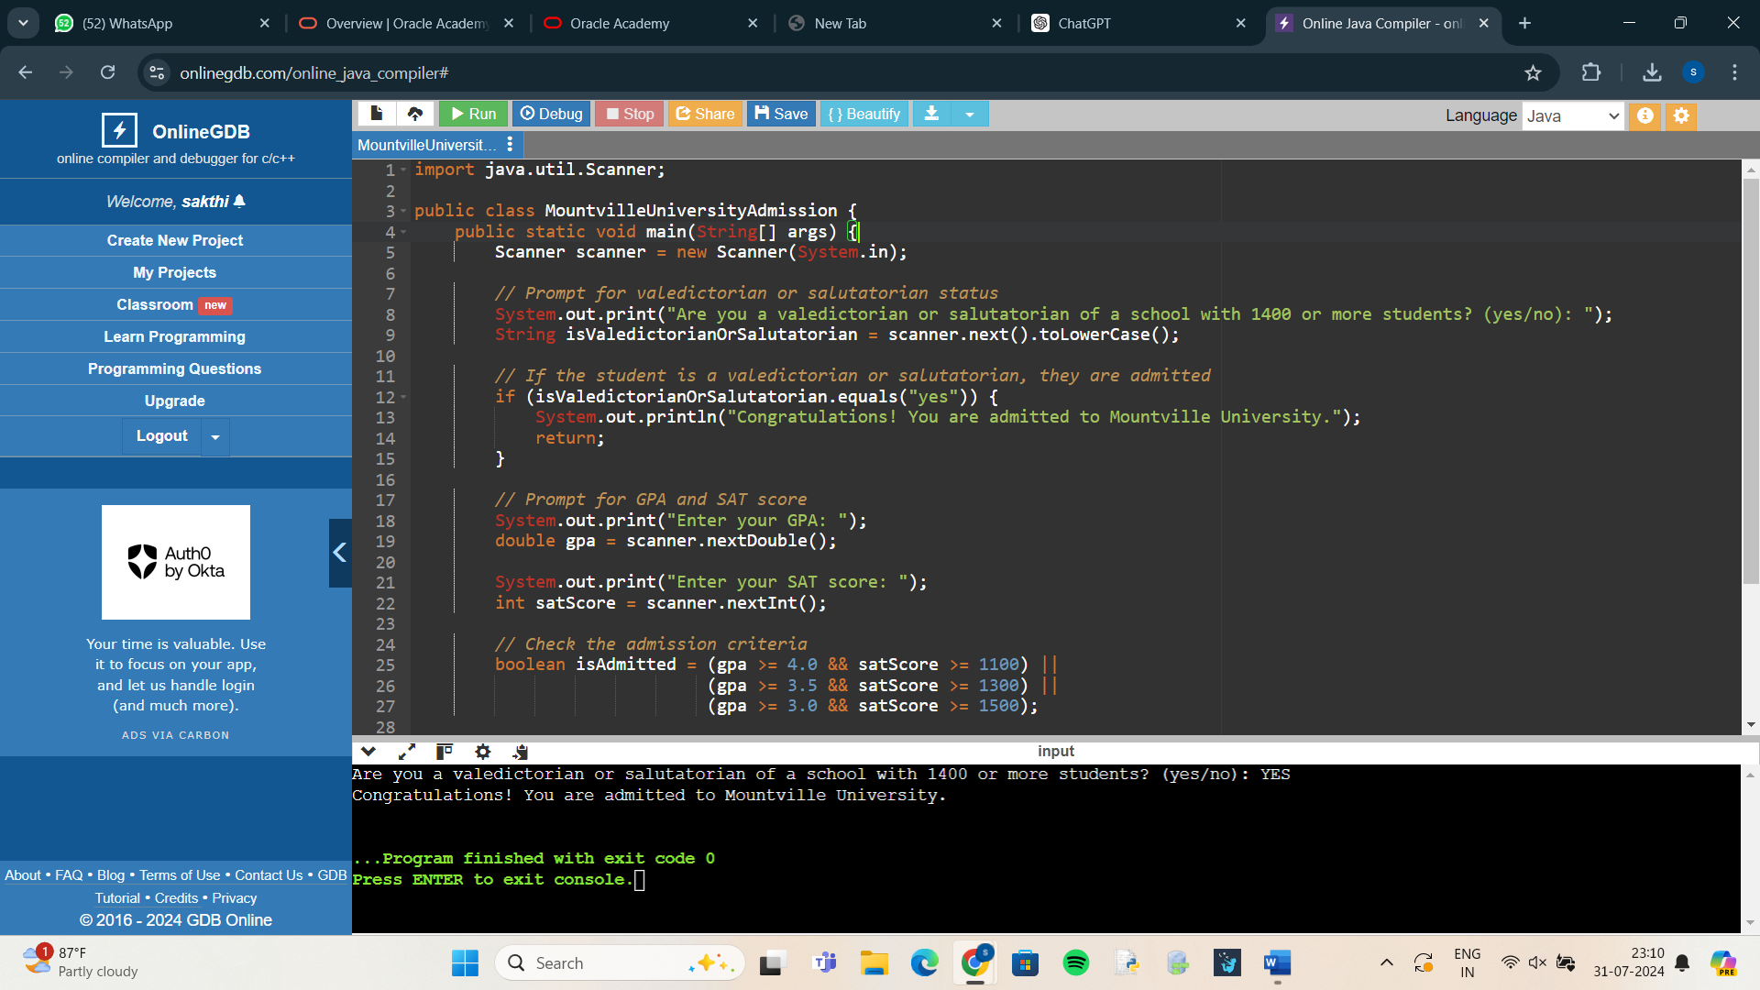

1. Write a program that calculates the number of buckets of paint to use for a room and the optimal number of cans to purchase. You need to ask the height of the room and the length and width of the room. The room is rectangular. You must paint the walls and the ceiling but not the floor. There are no windows or skylights. You can purchase the following size buckets of paint. • 5-liter bucket costs $15 each and covers 1500 square feet. • 1-liter bucket costs $4 and covers 300 square feet.

**ANSWER:**

import java.util.Scanner;

public class PaintCalculator {

public static void main(String[] args) {

Scanner scanner = new Scanner(System.in);

System.out.print("Enter the height of the room (in feet): ");

double height = scanner.nextDouble();

System.out.print("Enter the length of the room (in feet): ");

double length = scanner.nextDouble();

System.out.print("Enter the width of the room (in feet): ");

double width = scanner.nextDouble();

double wallArea = 2 * height * (length + width); // Area of four walls

double ceilingArea = length * width; // Area of the ceiling

double totalArea = wallArea + ceilingArea;

int fiveLiterBuckets = (int) Math.floor(totalArea / 1500);

double remainingArea = totalArea - (fiveLiterBuckets * 1500);

int oneLiterBuckets = (int) Math.ceil(remainingArea / 300);

int totalCost = (fiveLiterBuckets * 15) + (oneLiterBuckets * 4);

System.out.println("Total area to be painted: " + totalArea + " square feet");

System.out.println("5-liter buckets needed: " + fiveLiterBuckets);

System.out.println("1-liter buckets needed: " + oneLiterBuckets);

System.out.println("Total cost: $" + totalCost);

}

}

